3CD MAS Sample Examination

1. (2 + 2 + 3 + 2 = 9 marks)

Given the position vectors a = 2i + 6j – 3k and b = 3i – 4j + 12k, find

(a) the exact value of ⏐b⏐

(b) the vector in the same direction as a but equal in magnitude to b.

(c) the size of the angle between a and b.

(d) if c = 4i + λj – 8k is perpendicular to a, evaluate λ.

2. (3 + 3 = 6 marks)

The position vectors of points A, B and C are –i + 9j + 3k, 3i + j – k and
6i – 5j – 4k respectively.

(a) Determine the ratio 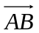: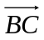.

(b) Find the position vector of the point P such that 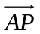: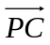 is 3: -2.

3. (1 + 2 + 3 = 6 marks)

In the diagram below, is the centre of the circle and is a chord with midpoint. The vectors and are denoted by and respectively.

O
B
A
M

(a) Express in terms of and .

(b) Express in terms of and.

(c) Use vector methods to prove that is perpendicular to .
4. (7 marks)

In triangle ABC, point D lies on BC such that CD : DB = 2 : 1.
Let  = b and 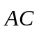 = c and the point E be such that 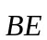 = 3b + 2c.

Prove that the points A, D and E are collinear and determine the ratio AD : DE.

5. (11 marks)
For each of the following functions, find .
(a) 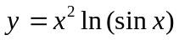

[3]
(b) 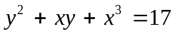

[4]
(c) 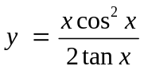

[4]
6. (3 marks)

Simplify | 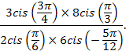

7. (2 + 3 + 2 = 8 marks)
Sketch the following regions in the complex plane.
(a)

(b)

(c) For the region in (b) above, state the maximum value of

8. (2 + 2 = 4 marks)

P is the point with coordinates (2, 1, 1) and Q is the plane with equation .

(a) Give a vector equation for the plane that contains P and is parallel to Q.

(b) Give a vector equation for the line through P and perpendicular to Q.

9. (2 + 3 = 5 marks)

Point M has position vector 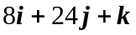and point N has position vector 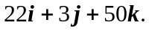

(a) Find, to the nearest degree, the angle between the vectors and .

(b) Find the position vector of the point P that divides internally in the ratio 2:5.

10. (6 + 3 = 9 marks)

A small rocket is fired at noon, from position kilometres, with a constant velocity of
kilometres per minute. A stationary weather balloon is at position kilometres.
It is known that the rocket just misses the balloon.

(a) Find

(i) at what time the rocket is closest to the balloon, to the nearest minute.

(ii) the distance the rocket and the balloon are apart at that time (to the nearest m).

A second rocket is also launched at noon, also with a constant velocity, but is fired from position kilometres and aimed so as to collide with the first rocket at exactly 12.07 p.m.

(b) Determine the velocity of the second rocket that will ensure collision takes place at the required time.

11. (7 marks)

Michael is flying a kite. He is standing still and the kite is moving away from him at a constant height of 25 metres in a vertical plane that contains Michael (M) and the kite (K).
He keeps the string attached to the kite taut at all times, i.e., it forms the straight line segment MK, as shown in the diagram below. At a certain moment the length of the string is 65 metres and is increasing at a rate of 1.2 metres per second.
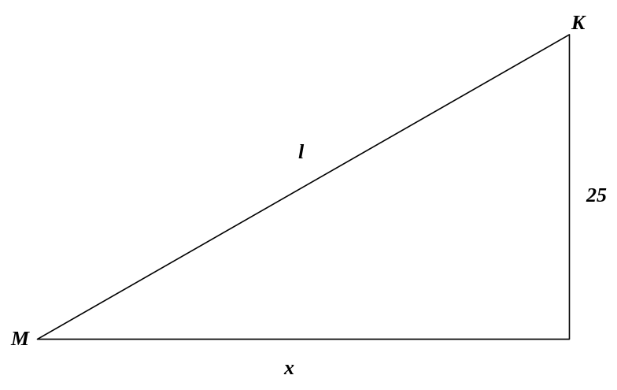
How fast is the kite moving at that moment?

12. (3 marks)

The diagram below shows the three graphs and where
are constants.
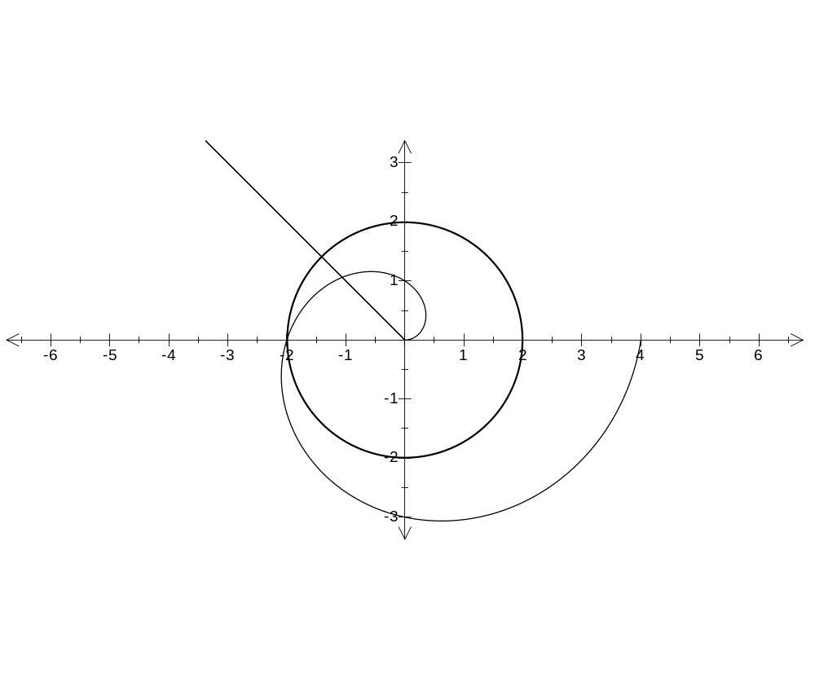
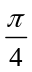
State the values of .
13. (1 + 2 + 1 = 4 marks)

A manufacturer sells three products, A, B and C, through outlets at two shopping centres, Eastown (E) and Noxland (N).

The number of units of each product sold per month through each shop is given by the matrix Q, where
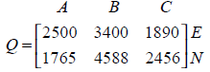

(a) Write down the order of matrix Q.

(b) The matrix P, shown below, gives the selling price, in dollars, of products A, B, C.

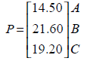

(i) Evaluate the matrix M, where M = QP.

(ii) What information does the elements of matrix M provide?

(c) Explain why the matrix PQ is not defined.

14. (1 + 2 + 2 + 2 + 3 = 10 marks)

Let v = 6 + 8i and w = 7 + i.

(a) Plot the points corresponding to v and w on the diagram below, labelling them as V and W respectively.
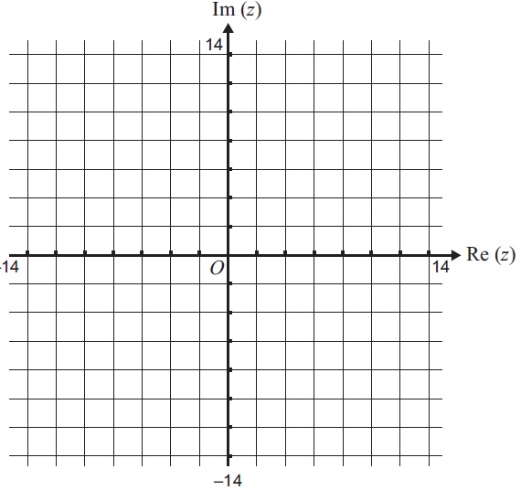

(b) Let S be defined by S = 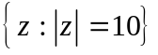 where z is a complex number.

(i) Show that v S.

(ii) Sketch S on the Argand diagram in part (a).
(c) Let u be such that 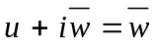. Find u in cartesian form.

(d) Sketch, on the Argand diagram in part (a), 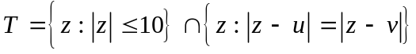.

(e) Use a vector method to prove that ∠OWV is a right angle.

15. (4 marks)

Express 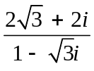 in polar form.

16. (4 marks)

Find matrix X if

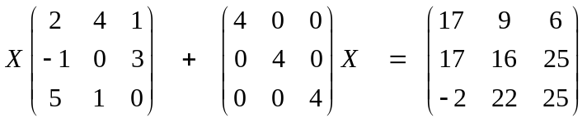

17. (2 + 4 = 6 marks)

The matrix M is defined by M = 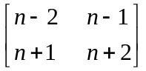

(a) Determine the product M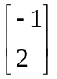

(b) Hence, or otherwise, solve the for x and y given that M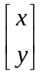 = 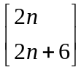
18. (4 marks)
If 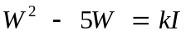, where I is the identity matrix and 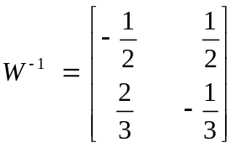,
determine the value of k.

19. (4 + 6 = 10 marks)

(a) Use the method of ‘proof by counter example’ to prove that if a and b are rational numbers, then so is a + b.

(b) Use the method of ‘proof by contradiction’ to prove that there are no positive integer solutions to the Diophantine equation x² – y² = 1.
(Note: A Diophantine equation is an equation for which you seek integer solutions.)

